Chapter 4, Problem 89.

Consider the circuit in Fig. 4.145. (a) Replace the resistor R_{L} by a zero resistance ammeter and determine the ammeter reading. (b) To verify the reciprocity theorem, interchange the ammeter and the 12-V source and determine the ammeter reading again.

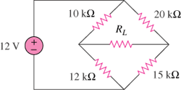

Figure 4.145
For Prob. 4.89.

